Review “ContextIoT”

Name: Wenhui Zhang

*Paper Name：*

Jia, Y. J., Chen, Q. A., Wang, S., Rahmati, A., Fernandes, E., Mao, Z. M., ... & Unviersity, S. J. (2017). ContexIoT: Towards providing contextual integrity to appified IoT platforms. In *Proceedings of The Network and Distributed System Security Symposium* (Vol. 2017).

**Contribution:**

This paper deploys system that provides contextual permission prompts in SmartThings apps, ContexIoT. ContexIoT is a context-based permission system for appified IoT platforms that provides contextual integrity by supporting fine-grained context identification for sensitive actions, and runtime prompts with rich context information to help users perform effective access control.

**Motivation:**

Design flaws in current IoT platform permission models have been reported recently, exposing users to significant harm such as break-ins and theft. Thus, a new access control model is needed for both current and future IoT platforms.

**Related works:**

Context concept various as following:

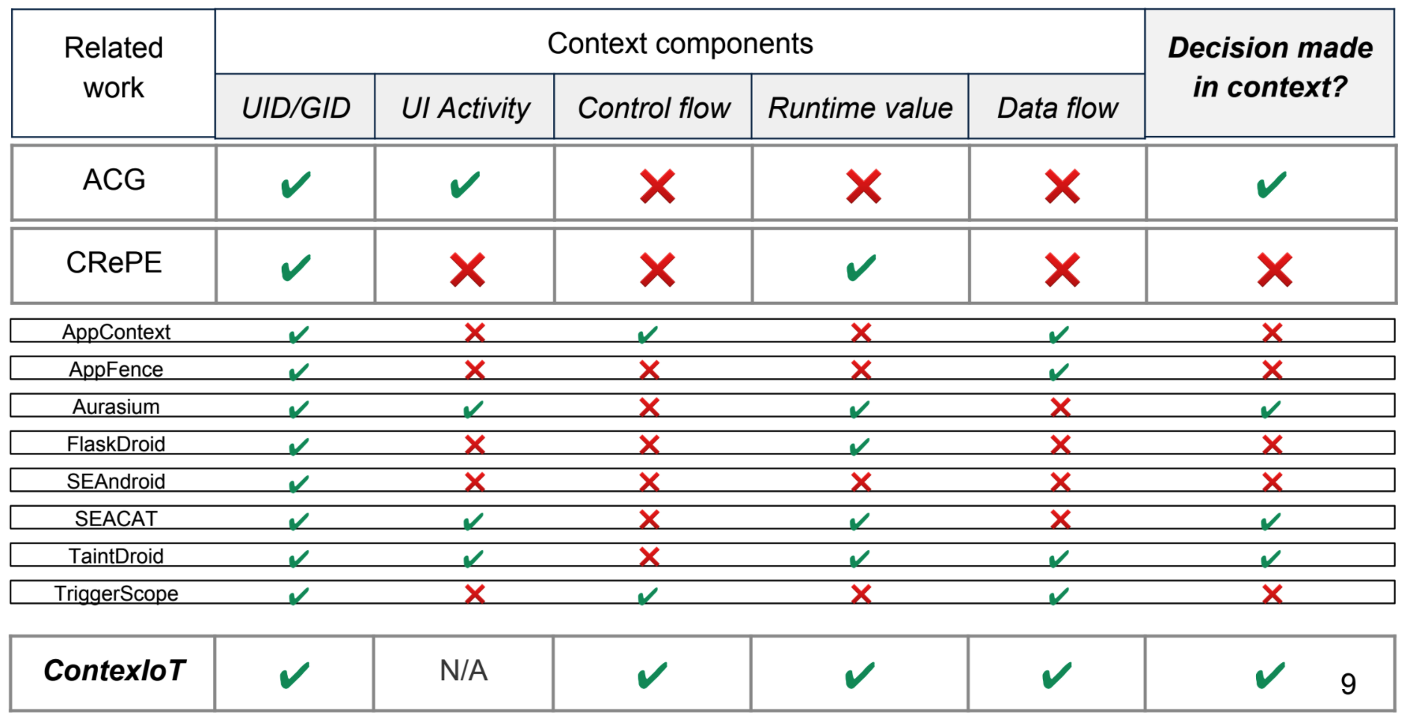

**Methodology:**

Context definition in ContexIoT is at the inter-procedure control and data flow levels.

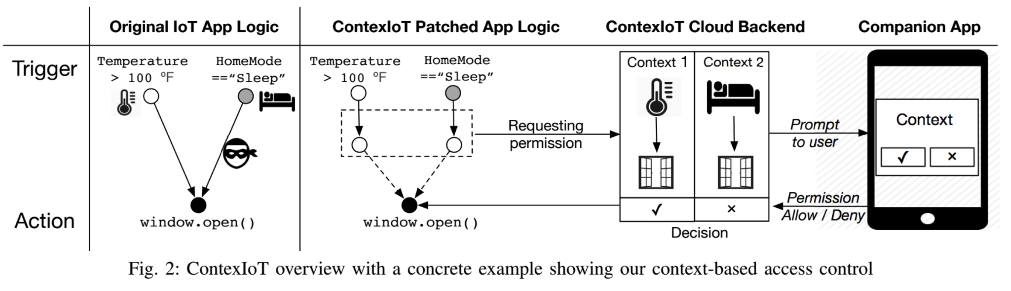

**Results:**

Evaluation is done on data set of Attacks Migrated From Mobile Platform

(<https://sites.google.com/site/iotcontextualintegrity/attack/existing-iot-attacks>).

**Take away:**

